REGISTRATION AT CAIS EPP WITH QUALIFIED ELECTRONIC SIGNATURE OWNED BY FOREIGN ECONOMIC OPERATORS
Requirements to the qualified certificates for qualified electronic signature, used for identification and signing in CAIS EPP:

Qualified certificates for qualified electronic signature are used in CAIS EPP for identification of persons, economic operators and contracting authorities/entities, as well as for signing electronic content in the system.
For successful registration in CAIS EPP it is necessary to meet the following technical requirements:

- D​igital signature should be issued by a authorized certification service provider included in the EU Trusted List, available at: https://webgate.ec.europa.eu/tl-browser/#/ (Information on authorized certification service providers in Bulgaria can be obtained at: https://webgate.ec.europa.eu/tl-browser/#/tl/BG​);
- Digital signature should be located on a secure device (smart card / SSCD), as the system does not accept cloud digital signatures;
- Correctly installed software for work with qualified certificates for qualified electronic signature on the workstation, according to the requirements of the respective certification service provider;
- Configured operational system and Internet browser for working with qualified certificates for qualified electronic signature on the workstation, according to the requirements of the respective certification service provider;
- Installed root certification chain for work with certificates of the respective certification service provider;
- Signing component should support the interface to the Windows CSP smart card and / or PKCS # 11 minimal version 2.2;
- Latest Java JRE version 8 should be installed from https://java.com;

For the purposes of electronic identification and electronic signing, it is necessary for qualified certificates for qualified electronic signature to include the following information:

- Digital signature should be certified as a Qualified certificate for electronic signature and the initials QCert for Esig should be visible against the signature;
- Element SerialNumber - unique identifier of the holder.
- Flag for KeyUsage: Digital Signature, Non-Repudiation - required for electronic signing.
- Flag for Extended KeyUsage: Client Authentication - required for authentication purposes.
REGISTRATION STEP BY STEP

Access to the system
CAIS EOP can be accessed from any modern browser at the following address http://www.app.eop.bg. In order to register at CAIS EOP person or the business entity must have valid qualified electronic signature. The signature should be issued on a device, e.g. smartcard, usb flash drive.
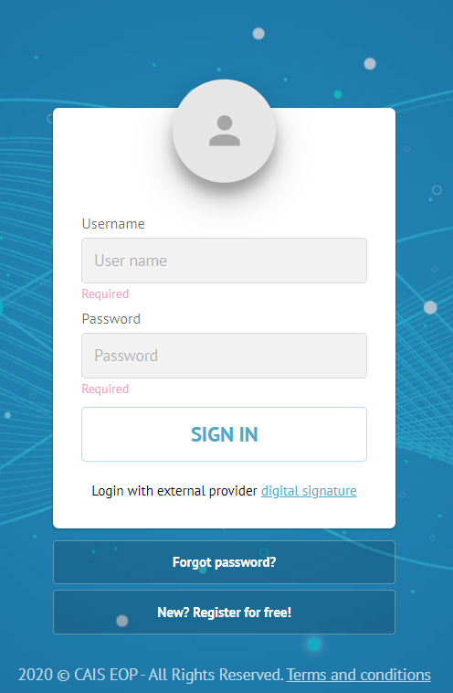

Register at CAIS EOP
Step 1: Any person can start the registration process in CAIS EOP by clicking the ”New? Register for free!” button on login page
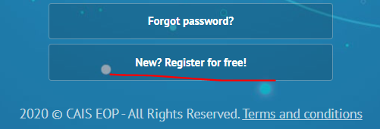
Step 2: System forwards the individual to a page where they select type for the business entity that will be registered in the system from the following options:
- Public Buyer – Option is reserved only for Bulgarian public procurement authorities
- Supplier – Applicable in cases when a person needs to register a supplier organization in the system. This type of registration creates a user profile for the person as well
- Profile (without registry number) – Applicable in cases when a person need to create a user profile in CAIS EOP, without creating supplier organization in the system.
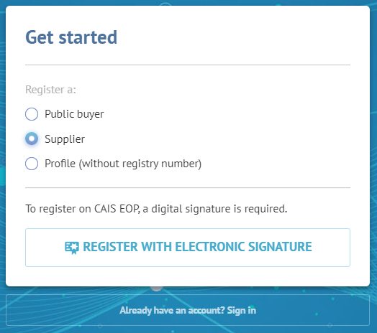
Step 3: Person clicks on the “REGISTER WITH ELECTRONIC SIGNATURE” button. Note: Person must insert their qualified electronic signature into computer to proceed with the next step. System will not allow registration with a cloud qualified electronic signature.
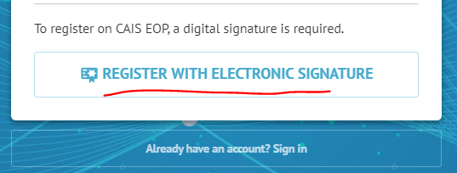
Step 4: After successfully applying qualified electronic signature, system forward the person to a screen where they need to fill out personal and organization data as well as valid email, username and password.
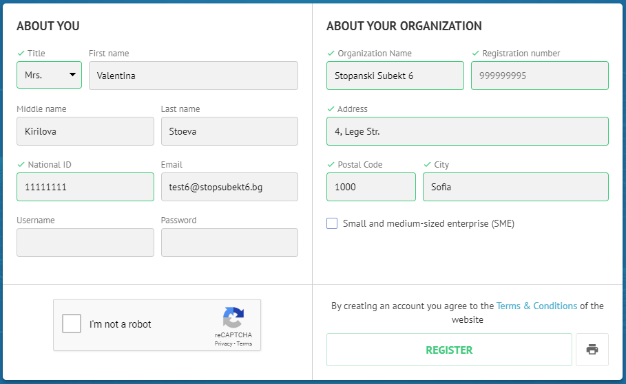
NOTE: System automatically takes any available data for the person or the organization from the qualified digital signature. If the person only registers a user profile, system doesn’t require filling out organization data.
Step 5: After completing the form person need to click the “Register” button. CAIS EOP gives the person indication if the registration process is successful and send sends activation email to the email address previously filled out by the person.
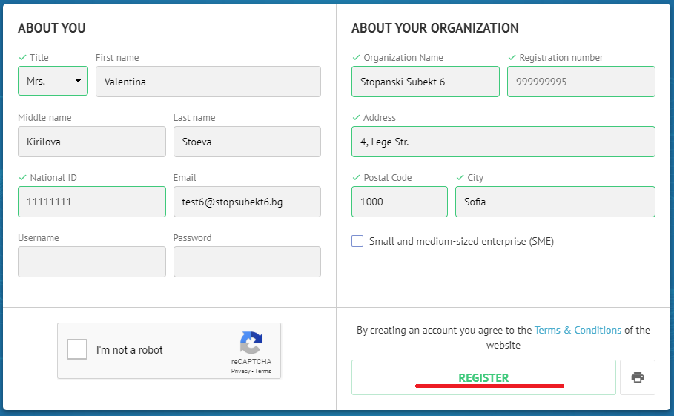

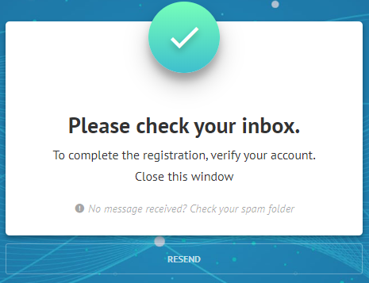
Step 6: Person must click the activation link in the email address. CAIS EOP gives an indication on successful activation.
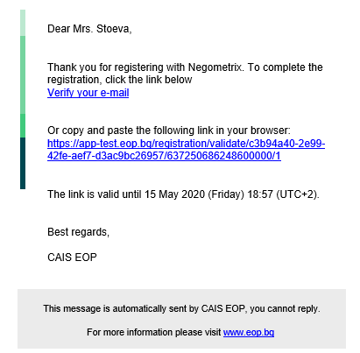

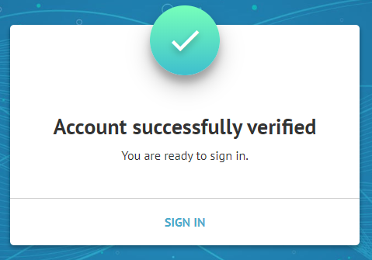
NOTE: Each activation link has validity period of 24 hours. If this period has passed the system gives an idication about it and allows the user to receive a new activation email by clicking option “RESEND”
